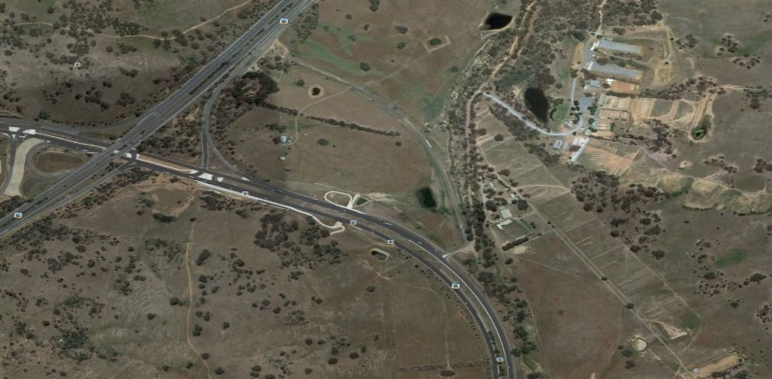
Canberra
Range
Airport

ACT Smallbore range

Turn off the Federal highway onto Majura parkway as if going to the Airport. The turnoff is close to the ACT/NSW border. The range is located on Hector McIntosh Grove off Majura Parkway about 500 m from the Highway.

The range can be seen as you turn off Majura Parkway. Hector McIntosh Grove has been upgraded and sealed. Follow the road and cross the creek then veer right at a tee intersection to a white picket fence and gate. Proceed via a gate immediately to the right after the cattle grid.

To go north from the range, turn left on a small one way road off Hector McIntosh grove that leads to the Federal highway off ramp, turn right then follow the signs.
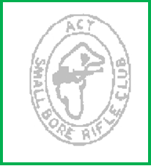

Open Championship

Friday 6 March 2026
Saturday 7 March 2026
Sunday 8 March 2026

Entry Fees
1 event $30
2 events $50
3,4 events $60
5,6 events $70

Information

- NSWSARAI (or other TRA State) membership card and current firearm licence must be shown on entry.

- ISSF and TRA rules apply.

- Junior has not reached their 21st birthday on day of match

- Veteran over 60 before the day of the match.

- The Club reserves the right to vary the prize list and number of shots per match and squad timing depending on entries. (10 target range)

- Refreshments and light snacks available during the day.

- Camping available at range for a fee (Canberra Rifle Club), prior notice requested.

- Winners receive Medallions as per program.

- BBQ Friday and Saturday nights

Further information

R Marshall 02 6241 2833
bobmarshallsb@ bigpond.com

ACT Smallbore Rifle Club
PO Box 7298 Kaleen ACT 2617

 | Friday
1 pm | Air Rifle, self-squadding. (Last start 4 pm)  Grades A B C & D, 1st 2nd and 3rd J, V.
1 pm | Air Rifle, supported, self-squadding. (Last start 4 pm)  Grades A B C: 1st 2nd and 3rd.
1 pm | 20 m Prone (40 shot) (Last start time 4:30 pm)  Grades A B C & D, 1st 2nd and 3^{rd,}  Last start time reserved for visitors
1 pm | 20 m Bench (40 shot) (Last start time 4:30 pm)  Grades A B & C, 1st 2nd and 3^{rd,}  Last start time reserved for visitors
 | Saturday
9 am | Air Rifle continues. (Last start 3 pm)
9 am | 50 m Bench (Open Target)  Grades A B & C, 1st 2nd and 3rd  Entries close 11 am
1 pm  Aprox | 3 position 3X20  Grades A, B & C; 1st 2nd and 3rd J, V
 | Sunday
9 am | Air rifle continues (last start 11 AM)
9 am | 50 m Prone  Grades A, B, C & D; 1st 2nd and 3rd J, V, Last entry 11am

