

**Sutherland Shire Small Bore Rifle Club**

invites you to the

2025 Illawarra Open Championship for Benchrest & Prone Shooting

Saturday 1st November & Sunday 2nd November 2025

***The Joe Clements Memorial Range***

***1-19 Newland Place, YARRAWARRAH, NSW***

**Sponsored by Sydney Business Insurance, Safari Firearms and Peps Auto Spares Engadine**



**Saturday 1st November: Illawarra Open Benchrest Championship**

* 60 shot event w/ 3 squads of 30 minutes each for “Open Class” benchrest targets
* TRA Supplementary Rifle Rules will apply.
* Shooting commences at 09:00am, with entries closing at 11:00am
* Competitors must be registered members of NSWSARAI or like recognised associations/clubs.
* Entry Fee of $30 *
* Medals for 1st to 3rd in A, B, and C Grades

**Sunday 2nd November: Illawarra Open Prone Championship**

* 60 shot English Match w/ 3 squads of 30 minutes each.
* ISSF/TRA Supplementary Rifle Rules will apply, except for clothing.
* Shooting commences at 09:00am, with entries closing at 11:00am
* Competitors must be registered members of NSWSARAI or like recognised associations/clubs.
* Entry Fee of $30*
* Medals for 1st to 3rd in A, B, C, and D Grades
* Club Teams - 3 shooters per Team (Team members are to be nominated prior to shooting)
* Perpetual Trophy for the Open Prone Champion, and for the winning Club Team.

**NOTE: Entry fees multiple events $50.00 for both prone and bench.**

**\*\*\*\*\*\* Sporter/Field Grade/Bunny Gun\*\*\*\*\*\***

**(fun shoot)**

Shooting position can be prone or bench.  
Great prizes for 1st, 2nd and 3rd places so don’t miss out.

(Prizes will be displayed on the days).  
Shooting will commence on Saturday after bench and Sunday after Prone squads.   
One card per shooter (you will only have one go, so make it a good one).  
Targets will be 50M English match prone targets. (see attached) Unlimited sighters, five rounded in each target total of twenty scoring rounds. Please note once you start your scoring shots you cannot go back to sighters.

**Entry fee $20.00**

1. Rifles must be off the shelf .22 Cal (what you would use to shoot rabbits in the field)  
   2. No heavy barrel target rifles  
   3. The range officer will inspect rifles to ensure the spirit of the competition is followed and equal for all shooters.   
   4. Ammunition must be .22 Cal subsonic. (under 1100 fps)5. Magazines can be used BUT only one round at a time.
2. Sights to be on 6 power maximum.

7. No barrel tuners/muzzle brakes.  
8. Only front bipods can be used.  
9. Rifles must be under 4.5kg with sights (not including bipod.  
10. No rear bags can be used. Rifles must be at the shoulder when firing.   
11. Spotter scopes can be used.

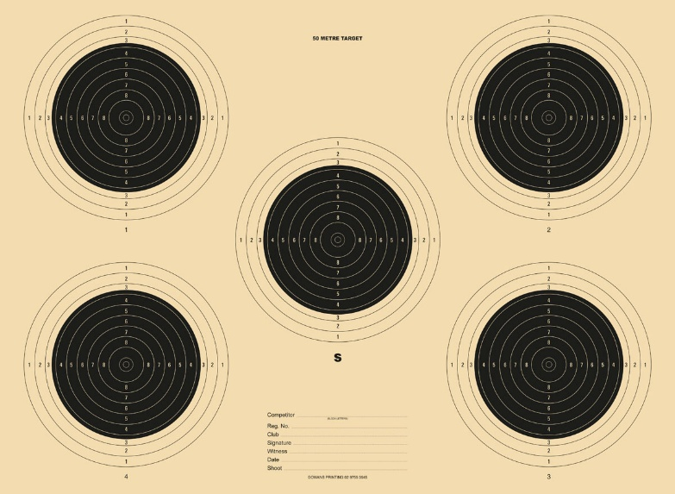

**Security Information**

* Competitors must produce current Category A Firearms Licence (Target Shooting) when registering, along with NSWSARAI or association/club membership grading card.
* Non-NSWSARAI members are required to sign the Visitors Book
* Strict safety rules will be enforced owing to the populated surrounds. Prone shooters are to give particular attention to ensuring rifles are on the shoulder and pointed directly at the target before their breech is locked.
* All rifles must be singularly loaded (i.e.: magazines / clips cannot be used) * *not applicable to bunny shoot.*

**\*\* Firearms are to be under your direct control and / or locked securely in your vehicle when not in use**

**\*\* All Rifles must have a breech flag inserted when not in use or the bolt removed**

**\*\* When shooting is taking place all shooters and those observing are under the direct control of the Range Officer.**

**General Information**

* Food & refreshments will be available on both days.
* Time limits may be varied depending on the number of competitors.

