 ***NSW RBA Championship 2023*** 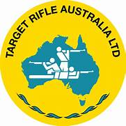

West Wyalong Small Bore and Air Rifle Club will be hosting this competition on Saturday 6/7 May 2023 at 25 Operator Street West Wyalong.

Match - 3 RBA cards with rotating details as per WRABF Rules and limited to a max of 42 shooters

Classes being International Sporter, HV, and Air Rifle - LV.

Practice Friday after 3pm.

Flag set up from 7.00am START TIME 9.00am Saturday, LV Air at 25m, International sporter at 50m.

8.00am Sunday, HV at 50m.

Medals 1st, 2nd and 3rd in Open and Juniors + Top 10 patches for combined classes

Match Fees: $25 Adult - $15 Junior, Per class.

Shooters wishing to participate are to register with Glenn Seaman on 0427 639 717 (President) or via email: Westwyalongrifleclub@hotmail.com

Please also advise of sharing arrangements when nominating.

Canteen is available on Saturday and Sunday at Lunchtime and Breakfast on Sunday.

Camping available for $10 per day. Advise if camping when registering. Accommodation on back.

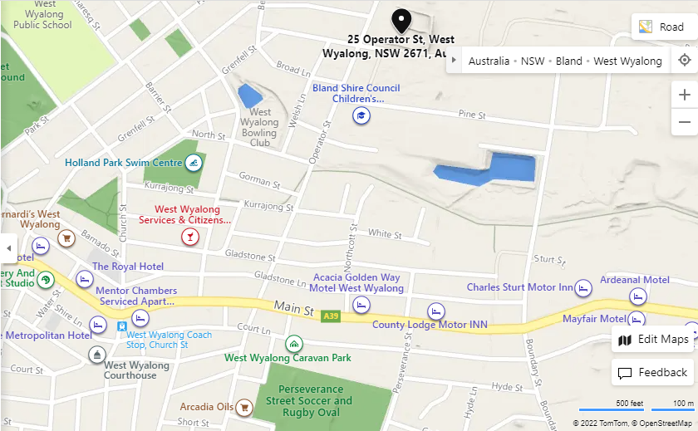Dinner on Saturday at White Tank Hotel.

**Accommodation:**

**Acacia Golden Way Motel Mayfair Motel**

**02 69722155 02 69722788**

**Ace Caravan Park Mentor Chambers B&B**

**02 69723061 02 69722187**

**Ambassadors True Blue Motor Inn Metropolitan Hotel**

**02 69722588 02 69720400**

**Ardeanal Motel Royal Hotel west Wyalong**

**02 69722777 02 69724337**

**Cameo Inn Motel Tattersall’s Hotel**

**02 69722255 02 69722030**

**Charles Sturt Motor Inn The Bank B&B**

**02 69722422 0409 394 249**

**Club Inn Resort The Palms Motel**

**02 69722000 02 69722477**

**Country Roads Motor Inn West Wyalong Caravan Park**

**02 69722300 02 69723133**

**County Lodge Motor Inn White Tank Hotel**

**02 69722411 02 90512637**

Sponsors: White Tank Hotel, Wyalong Machinery, Cleaning and Caretaking Corporation.